PROJECT FILE OF DIGITAL LITERACY


NAME: YUVIKA MUKHERJEE
REG NO: 25BSA10071
BRANCH: CSE (CLOUD COMPUTING AND AUTOMATION)
YEAR: FIRST
COURSE CODE: CSE0001
DATE: 31/3/26

INTRODUCTION
Digital literacy is the ability to use digital tools and technologies effectively in everyday life. It helps individuals access information, communicate, and solve problems using digital platforms. In today’s world, being digitally literate is essential for education, work, and personal growth. It enables people to use technology safely, responsibly, and productively.
This project is based on the scenario of being selected as a Student Digital Ambassador, where the responsibility is to guide fellow students in understanding and navigating the digital world effectively. The main objective of this assignment is to create a detailed Digital Literacy Portfolio that reflects both theoretical knowledge and practical application of important digital skills.
The project is divided into five key tasks, each focusing on a different area of digital literacy. These tasks include designing an awareness infographic, developing a student digital portfolio, exploring coding and collaboration platforms, writing professional emails with proper etiquette, and preparing a cybercrime awareness case study along with preventive measures.
All the work is systematically organized in a GitHub repository, which promotes proper documentation, management, and collaboration. Through this project, the goal is to improve digital communication skills, increase awareness about online safety, and strengthen technical abilities, while encouraging students to use digital tools in a responsible and professional manner.
TASK-1

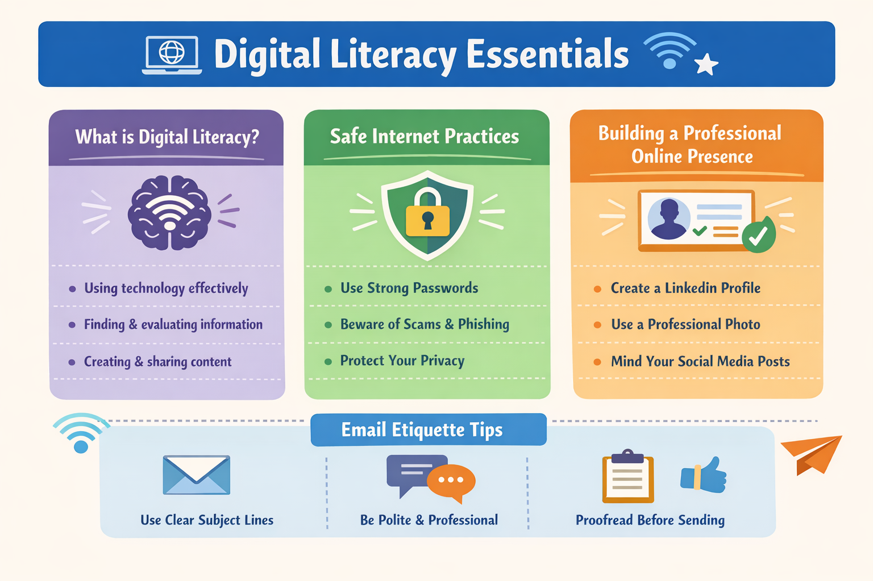

I created this infographic using Canva, as it provides easy-to-use templates, icons, and design elements that help in making visually appealing content. The tool allowed me to organize information clearly while maintaining a clean and professional look.
My design focuses on key aspects of digital literacy. It includes a section explaining what digital literacy means, highlighting skills like using technology effectively and evaluating information. Another section covers safe internet practices, such as using strong passwords, being aware of scams, and protecting personal data. I also included a part on building a professional online presence, emphasizing the importance of a good profile, appropriate content, and responsible social media use. At the bottom, I added email etiquette tips like writing clear subject lines, being polite, and proofreading messages before sending.
One thing I found interesting while making this infographic was how design elements like colors, icons, and layout can make information easier to understand and more engaging. However, it was slightly challenging to keep the content concise while still including all the important points.

TASK-2

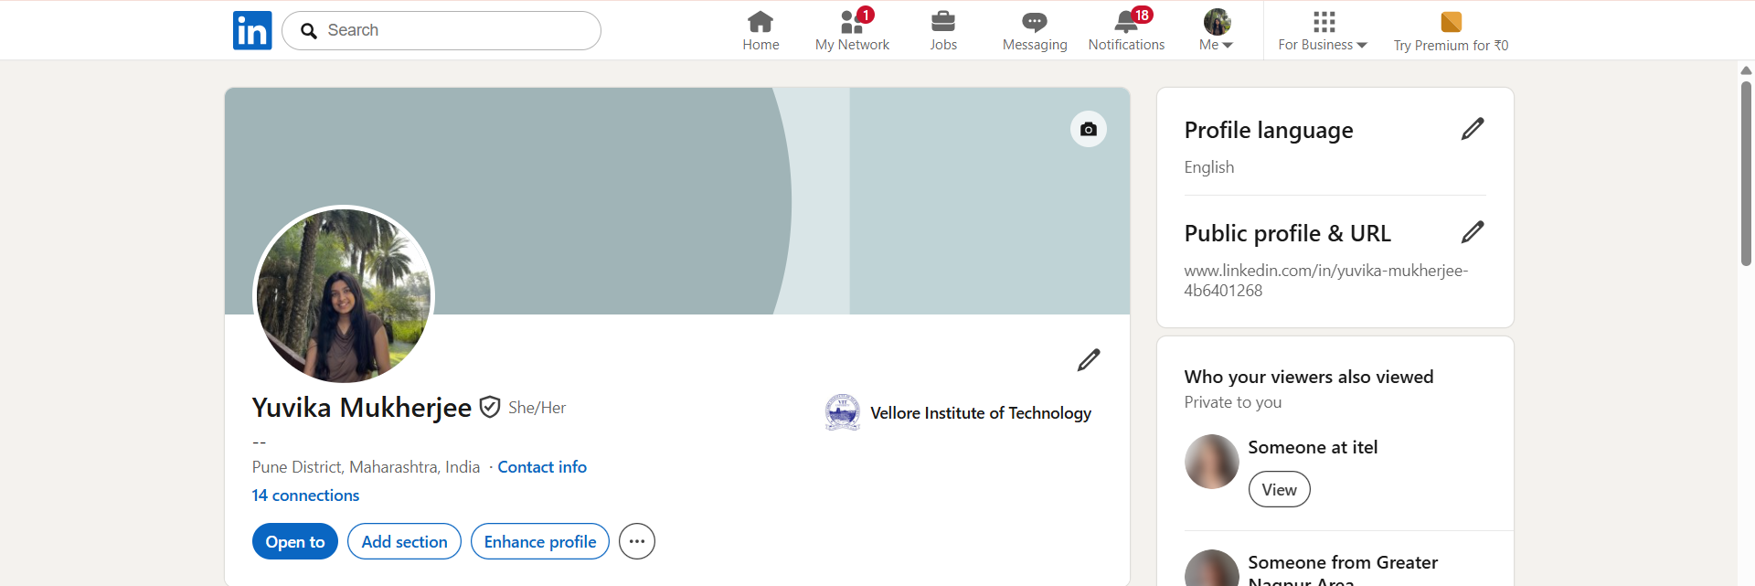
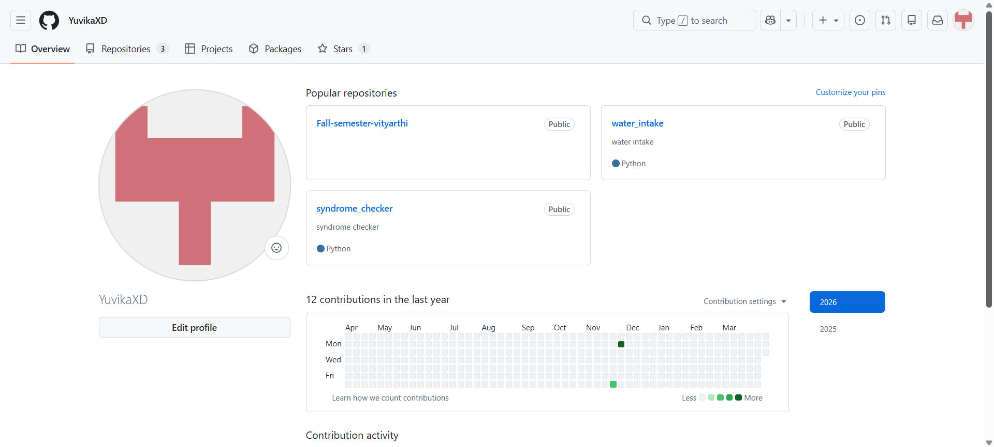
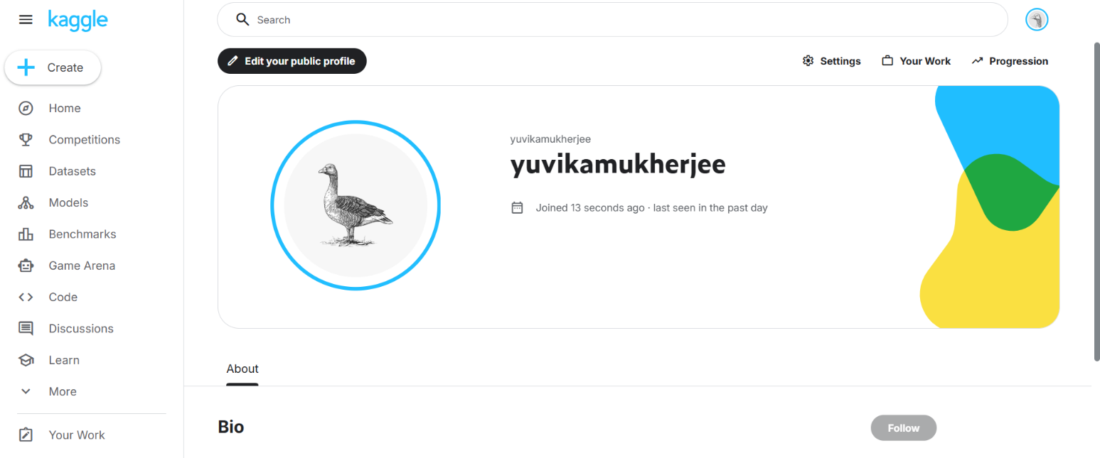

For my digital portfolio, I chose LinkedIn, GitHub, and Kaggle as the three primary platforms. LinkedIn is mainly used for building a professional online presence, networking with industry professionals, and showcasing academic achievements and skills. GitHub is a platform for hosting and managing code, where I can store my projects, track progress, and collaborate with others. Kaggle is widely used for data science and machine learning, offering datasets, competitions, and practice opportunities to improve analytical skills.
Over the next four years, I plan to actively develop and maintain these platforms. On LinkedIn, I will regularly update my profile with new skills, certifications, and experiences while connecting with professionals in my field. On GitHub, I aim to upload my academic and personal projects to build a strong portfolio that reflects my technical growth. On Kaggle, I plan to participate in competitions, work with datasets, and enhance my problem-solving abilities. Together, these platforms will help me build a strong digital presence and prepare for future career opportunities.

Task 3
Part A
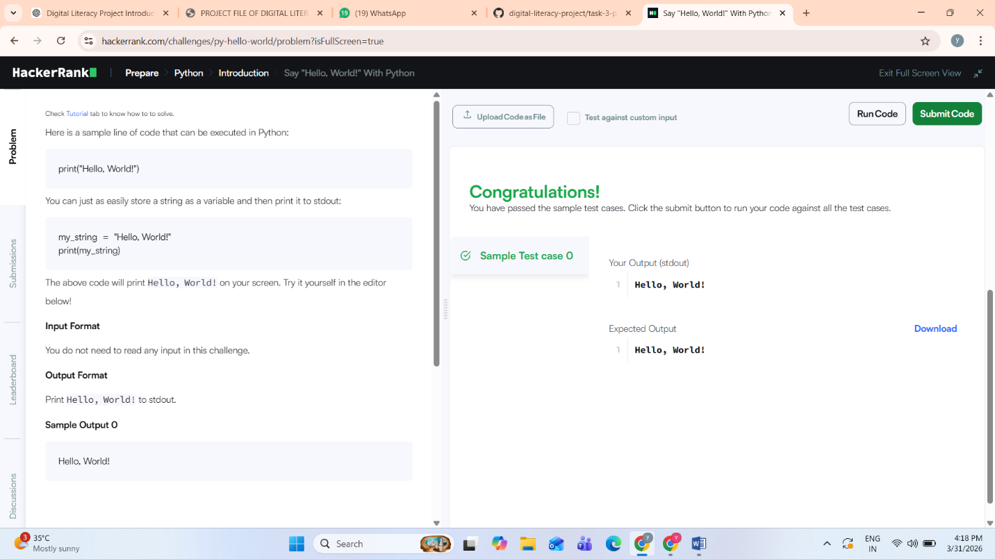

PART B
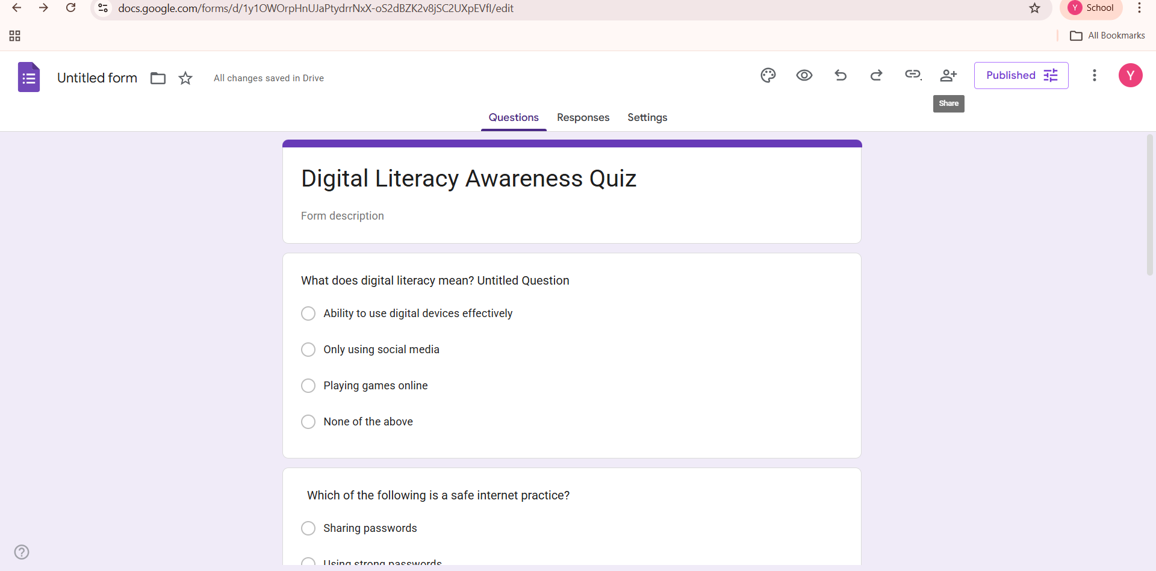

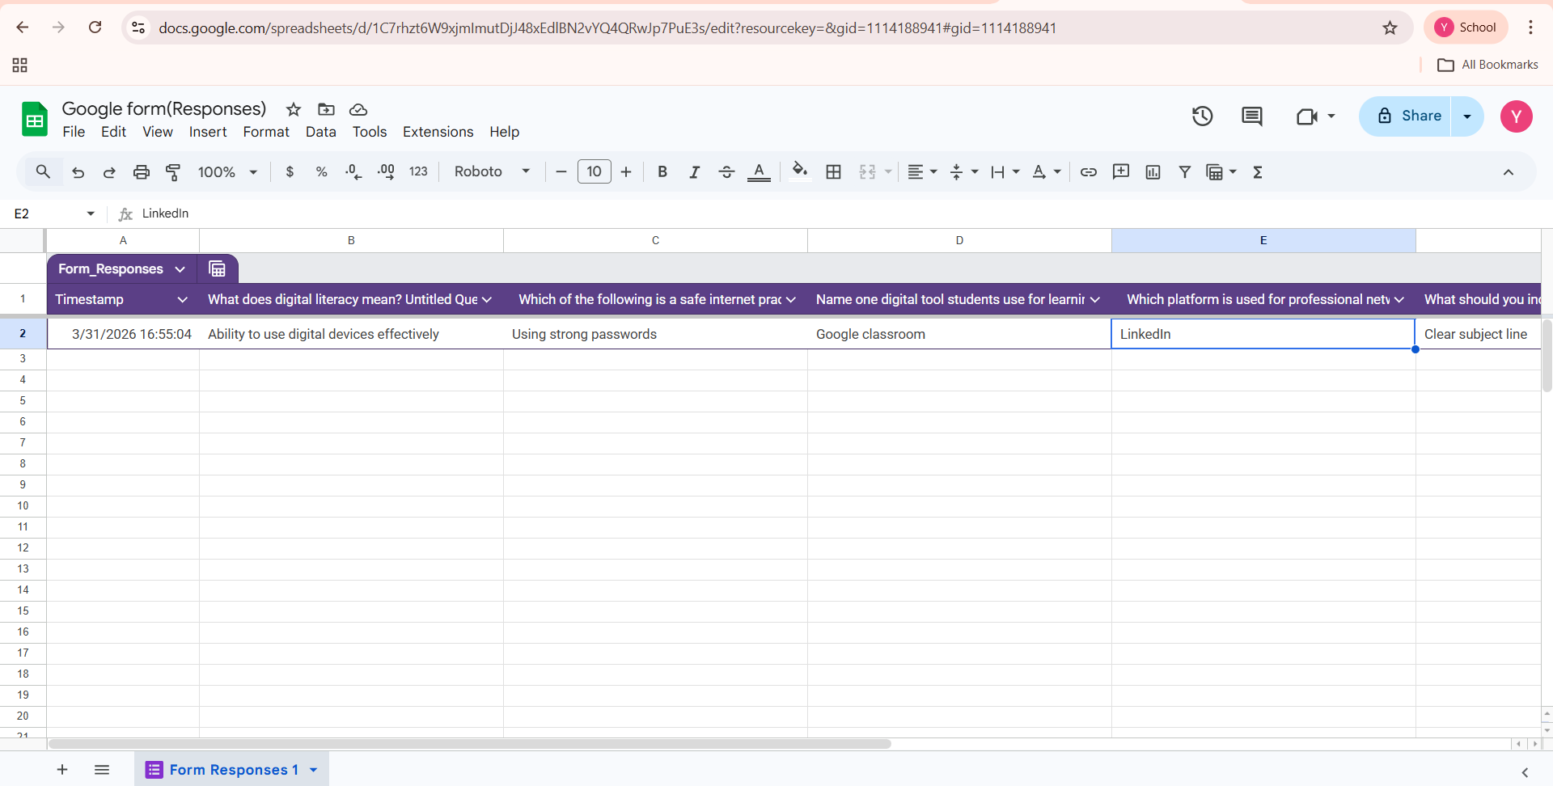

I used HackerRank and Google Forms as part of this task. On HackerRank, I practised a beginner-level coding problem, which helped me understand basic problem-solving and improve my coding skills. It was a good introduction to how coding platforms work and how solutions are tested using multiple test cases.
For collaboration, I used Google Forms to create a Digital Literacy Awareness Quiz consisting of five questions. The form included multiple-choice and short-answer questions to test basic understanding of digital literacy concepts. I also linked the responses to a Google Sheet, which helps in organizing and analyzing data efficiently.
These tools will be very helpful for my academic journey. Coding platforms like HackerRank will improve my programming and logical thinking skills over time. Google Forms will help me in conducting surveys, collecting feedback, and working on group projects. Overall, these platforms enhance both technical and collaborative skills, which are essential for my future studies and career.

TASK-4
PART A
Email-1
Subject: Request for Extension on Assignment Submission

Dear Professor,
I hope you are doing well. I am writing to request a short extension for the submission of my assignment for your course.
Due to unforeseen circumstances, I was unable to complete the assignment on time. I am working on it sincerely and would like to submit my best work. I kindly request you to grant me an extension of a few days to complete and submit the assignment.
I apologize for any inconvenience caused and assure you that I will adhere to the new deadline strictly.
Thank you for your understanding.

Yours sincerely,
Yuvika Mukherjee
[25BSA10071]
First Year, [CSE(cloud)]

Email 2
Subject: Application for Summer Internship Opportunity

Dear Sir/Madam,
I hope this message finds you well. I am a first-year B.Tech student at VIT Bhopal University, and I am writing to express my interest in a summer internship opportunity at your organization.
I am currently developing my skills in programming and digital technologies and am eager to gain practical experience in a professional environment. I am highly motivated to learn, contribute, and enhance my knowledge through this internship.
I would be grateful if you could consider my application for any available internship roles. I am willing to learn and adapt quickly to new challenges.
Thank you for your time and consideration. I look forward to your response.
Yours sincerely,
Yuvika Mukherjee
[25BSA10071]
VIT Bhopal University

PART B
Social Media Do's and Don'ts

DO's:
- Maintain a professional profile and username
- Share useful and positive content
- Think before posting anything online
- Respect others' opinions and privacy
- Use privacy settings to protect personal information

DON'Ts:
- Do not share personal or sensitive information publicly
- Avoid posting offensive or inappropriate content
- Do not engage in online arguments or trolling
- Avoid spreading fake news or unverified information
- Do not misuse someone else's content without permission

PROJECT REPORT

Poor digital communication can lead to serious misunderstandings and problems. For example, if a student sends an email to a professor without a proper subject line, greeting, or respectful tone, it may appear rude or unprofessional. This can result in the professor ignoring the email or forming a negative impression of the student. In some cases, important requests such as deadline extensions or clarifications may not be considered due to improper communication.
This situation could have been handled better by following basic email etiquette. The student should use a clear subject line, a polite greeting, and a well-structured message explaining their request. Proper sign-off and respectful language are also important. Effective digital communication ensures clarity, professionalism, and better chances of receiving a positive response.

TASK 5
PART A
Cybercrime Case Study: Phishing Attack

Phishing is a type of cybercrime where attackers try to trick individuals into sharing sensitive information such as passwords, OTPs, or banking details by pretending to be a trusted source.

In a typical phishing scenario, a student receives an email or message that appears to be from their bank or a popular payment app. The message may claim that there is an urgent issue with their account and ask them to click on a link. When the student clicks the link, they are redirected to a fake website that looks very similar to the original one. The student then enters their login credentials or OTP, which is directly captured by the attacker. The attacker then uses this information to access the victim’s account and perform unauthorized transactions.

Phishing attacks usually target students, working professionals, and elderly people who may not be fully aware of such scams. The consequences can include financial loss, identity theft, and misuse of personal information.

This case highlights the importance of being cautious while clicking on unknown links and verifying the authenticity of online sources before sharing any sensitive information.

PART B
Stay Safe Online – Prevention Checklist
- Do not click on suspicious links received via email or messages
- Always verify the sender before sharing personal information
- Use strong and unique passwords for different accounts
- Enable two-factor authentication wherever possible
- Never share OTPs, PINs, or banking details with anyone

Financial / UPI Safety:
- Do not approve unknown payment requests on UPI apps
- Always verify the receiver’s details before sending money

- Avoid using public Wi-Fi for financial transactions
- Keep your devices updated with latest security patches
- Log out from accounts after using shared devices

Reporting Cybercrime:
- National Cyber Crime Portal: https://cybercrime.gov.in
- Helpline Number: 1930

While researching cybercrime, I was surprised by how easily people can fall victim to phishing attacks. Many scams look extremely genuine, making it difficult to differentiate between real and fake messages. I realized that even a small mistake, like clicking on an unknown link, can lead to serious consequences such as financial loss or data theft.
This task made me more aware of the importance of being cautious online. One habit I will personally change is avoiding clicking on links from unknown sources and always verifying the authenticity of emails and messages before taking any action. I will also ensure that I never share sensitive information like OTPs or passwords with anyone. Overall, this awareness will help me stay safe and also guide others in avoiding such cyber threats.

